**Employee Attrition Under the Microscope**

**Insights & Strategies to Retain Top Talent Report**

1. **Problem Identification**

In this analysis, we aim to answer some key questions:

1. What internal and external factors are driving employees to leave the company?
2. How can organizations develop effective strategies to retain their best people?
3. What insights and practical action plans can help reduce attrition and strengthen the workforce?
4. **Background & Business Context**

High employee attrition can have a serious impact on any organization. It leads to higher recruitment costs, the loss of valuable skills and experience, lower morale among remaining staff, and disruptions in daily operations. Understanding why employees choose to leave is essential for creating proactive strategies that help keep top talent on board.

1. **Data Understanding & Processing**

The dataset contains 1,470 rows and 35 columns. It includes several key features such as BusinessTravel, Department, DistanceFromHome, EnvironmentSatisfaction, JobInvolvement, JobLevel, JobSatisfaction, MonthlyIncome, WorkLifeBalance, and YearsSinceLastPromotion. These variables are crucial for understanding the factors that may influence employee attrition.

1. 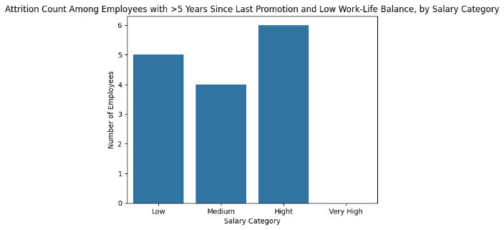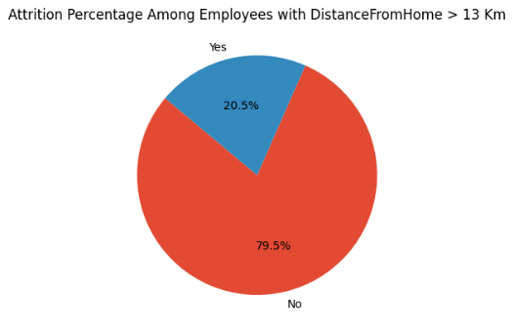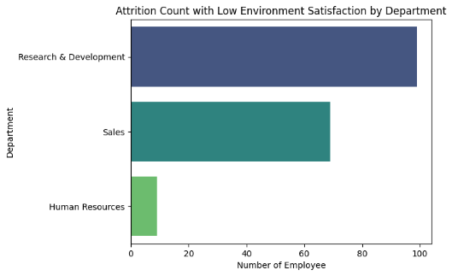**Exploratory Data Analysis (EDA) & Business In** **sight**

From the first exploratory data analysis, I discovered that the Research & Development department has the highest number of employees who left the company. Among those who resigned, 99 employees reported low levels of environment satisfaction within this department. This suggests there may be underlying issues affecting the work environment that need to be explored further to understand why employees perceive it so negatively.

In my second analysis, I investigated whether the distance between employees’ homes and the office influences attrition. Interestingly, the data showed that more than 70% of employees who live over 13 kilometers away still choose to stay with the company. This indicates that commuting distance does not appear to be a primary factor driving employees to leave.

Finally, the third analysis revealed that employees who have not received a promotion in the past five years and who experience poor work-life balance are more likely to resign, even if they earn higher salaries. This insight suggests that career growth opportunities and maintaining a healthy work-life balance are significant factors in retaining top talent.

1. **Conclusion**

The analysis reveals that employee attrition in this organization is driven by a complex mix of factors, including issues within specific departments, poor work-life balance, lack of career progression, and physical strain from long commutes and frequent travel. Addressing these challenges requires a comprehensive retention strategy focusing on improving work environments, ensuring fair and transparent promotion opportunities, reducing overtime, and offering support to employees facing long travel distances. By proactively tackling these issues, the company can reduce turnover rates, retain its top talent, and foster a more engaged and sustainable workforce.

1. **Recommendation & Action Plan**

**1. Improve Work Environment in Research & Development**

**Actions:**

* + Conduct anonymous employee surveys and focus group discussions specifically within R&D to identify specific issues (e.g. leadership style, workload, interpersonal conflicts).
  + Implement leadership and team-building training for managers and team leads in the department.
  + Create open communication channels where employees can safely express concerns or suggestions.
  + Monitor progress by re-assessing environment satisfaction scores quarterly.

**2. Enhance Work-Life Balance**

**Actions:**

* + Introduce flexible working hours and remote work options where possible.
  + Review workload allocation to prevent excessive overtime.
  + Promote awareness of mental health support services and encourage use without stigma.
  + Regularly track work-life balance metrics via pulse surveys.

**3. Establish Clear Career Development Paths**

**Actions:**

* + Develop transparent promotion criteria and communicate these clearly to all employees.
  + Launch regular career development discussions between employees and managers.
  + Create personalized development plans and identify training opportunities for skill growth.
  + Celebrate and publicly acknowledge promotions to motivate others.

**4. Address Long Commutes and Fatigue from Travel**

**Actions:**

* + Explore hybrid work arrangements for employees living far from the office.
  + Optimize business travel schedules to minimize frequency and duration where possible.
  + Offer commuting support (e.g. transportation allowances, shuttle services).
  + Monitor travel and commuting data to proactively identify at-risk employees.

**5. Support Early Career and Established Employees**

**Actions:**

* + Pair new employees with mentors to improve onboarding experiences and integration.
  + Identify challenges unique to each career stage and tailor support accordingly.
  + Evaluate whether workloads and expectations are realistic for newer employees.
  + Foster a sense of belonging through engagement programs and regular feedback sessions.

1. **Business Impact**

**1. Loss of Top Talent**

* Losing 91 top-performing employees out of 237 resignations represents a substantial loss of skills, institutional knowledge, and productivity.
* Replacing top talent is costly, time-consuming, and carries the risk that new hires may not reach the same performance levels.
* This can affect innovation, project delivery timelines, and overall business competitiveness.

**2. Increased Recruitment and Training Costs**

* High turnover rates in critical departments like Research & Development drive up recruitment costs due to frequent hiring needs.
* New hires require time to onboard and reach full productivity, causing potential delays in strategic projects and product development.

**3. Reduced Employee Morale and Engagement**

* A toxic work environment or low satisfaction in departments such as R&D can demotivate remaining employees, leading to lower engagement and performance.
* Negative workplace culture can also damage the company’s reputation, making it harder to attract high-quality talent in the future.

**4. Productivity Loss from Work-Life Imbalance**

* Employees experiencing poor work-life balance are at higher risk of burnout, absenteeism, and eventually resignation—even if they earn higher salaries.
* Prolonged overtime and long commutes decrease productivity and may lead to increased errors, lower quality of work, and missed deadlines.

**5. Threat to Workforce Stability and Strategic Goals**

* A significant portion of resignations among early-career and established employees threatens the stability of future leadership pipelines and succession plans.
* Without addressing these issues, the organization risks ongoing talent gaps that hinder achieving long-term business objectives.

**Financial Implications**

* The combined costs of turnover—including recruitment, onboarding, lost productivity, and potential project delays—can be substantial.
* Even conservative estimates suggest that replacing a single employee can cost between 50% to 200% of that employee’s annual salary, leading to significant financial impact when attrition is high.